Approach, Avoidance and Conflict Behavioural Task (AVC-BT)
Contents
Foreword 3
Quick Start Guide 6
1. Preparing your computer 6
2. Logging In 6
3. Choosing an experiment and generating a configuration......................................................7
4. Running the experiment........................................................................................................8
5. Glossary of result information in results export databases...................................................9
6. Understanding the six schedules.........................................................................................10

7. Understanding the structure of the three experiments.....................................................11
User Manual Part-1……………………..……………………………………….…………………………………………...……………12
1. Preparing your computer…………………………...……………………………………....………….………………13
2. Logging in…………………………………………...…………….…………………………………………………….………14
3. Defining gain/ loss schedules………………………………………………………………..………………....…….15
4. Create an experiment………………………………...………………….........................................……….19
5. Generate a configuration……………………………………………………………………………………….……….21
6. Install AVC-BT Client application, copy the configuration into the ‘Config’ folder and load the AVC-BT Client setup screen…….….…….......................................................................………23
7. Summarizing notes……………………………………………………………………………………………………..…..24
User Manual Part 2- AVC-BT Experiment Client Application User Guide...........................................26
1. Running the Experiment..........................................................................................................26
1.1 Experimenter Setup Stage and Waiting Screen..........................................................27
1.2 The Practice Session...................................................................................................28
1.3 Playing the Experiment...............................................................................................28
1.4 Clicking the Buttons / Timer Operation......................................................................29
1.5 Scoring........................................................................................................................29
1.6 Finishing the Experiment and exporting data.............................................................29
2. Uploading the Audio Files.................................................................................................................30
3. Calibrating the Volume.....................................................................................................................32
4. Troubleshooting................................................................................................................................32
4.1 Configuration Not Found............................................................................................32
4.2 Font Error....................................................................................................................32
4.3 Invalid Gain/Loss Settings...........................................................................................33
4.4 Results Upload Failed..................................................................................................33
4.5 Schedule/Run Error.....................................................................................................34
  - Sound Too Short..........................................................................................................34
  - Texture Error...............................................................................................................34
  - The Wrong Configuration File is Loaded.....................................................................35
5. Glossary of Result Information in Results Export Databases............................................................35
6. Written Instructions for Experiment Participants.............................................................................40

Foreword

This behavioural task has been designed to provide a flexible means to measure basic approach, avoidance and conflict behaviours. It allows the combination of conditions to contrast different levels of approach and avoidance tendencies, from strong approach (no/weak avoidance) to strong avoidance (no/weak approach) and, importantly, their conflict when these motivational tendencies are approximately equal. The theoretical impetus for the task comes from the Reinforcement Sensitivity Theory of Personality (for a review, see Corr, 2008; relevant papers may be accessed at: http://www.ueapsychology.net/sample-journal-articles-differential-psyc-pg33.html). Below is a summary of some of the relevant literature, and the theoretical foundations of the task.
Theoretical Foundations of Task

In general terms, ‘reward’ stimuli motivate approach behaviour, and ‘punishment’ stimuli motivate avoidance/escape behaviour (Gray, 1975). However, there are a number of complexities to be considered. At the state level, reward and punishment motivations (approach-avoidance tendencies) subtract from each other, and have different goal-gradients (Miller, 1944); and, in addition to these two systems, there is a third system of ‘avoidance’: over and above these subtractive effects: the inhibition of approach by approach-avoidance conflict is neurally and psychopharamcologically distinct from simple avoidance/escape (Gray, 1977, 1982; Gray & McNaughton, 2000). These two ‘avoidance’ motivations are controlled by two parallel processes: the Fight-Flight Freeze System (FFFS) and the Behavioural Inhibition System (BIS). Whereas the BIS is generally sensitive to anxiolytic drugs, the FFFS is relatively insensitive to anxiolytic drugs but sensitive to panicolytic ones (see McNaughton & Corr, 2008).
Such pharmacological data add support to a crucial point: in plain English, ‘behavioural inhibition’, if this means a reduction in behaviour, is not necessarily dependent on the BIS. When reward and punishment are not approximately equal in value, they subtract symmetrically (Gray & Smith, 1969), and resulting behaviour is specifically not affected by anxiolytic drugs (McNaughton & Gray, 1983); but when they approximately equally then the BIS is activated and these drugs affect it. The simple inhibition of behaviour occurs in the absence of the BIS, when the level of conflict is low (Okaichi & Okaichi, 1994). Thus, the processing of conflict and the resultant behavioural inhibition is not the same as simple (pure) avoidance, although in both cases it appears that behaviour is inhibited (Gray & McNaughton, 2000).

An important implication of the above is that, in order to study this conflict-related behavioural inhibition proper, it is important first to characterise and measure simple approach and avoidance and, then, to compare the effects of behavioural inhibition superimposed on these pure forms of approach and avoidance. The AVC-BL allow for this important experimental requirement.

Arousal and paradoxical effects on reward and punishment-mediated behaviour
Activation of reward and punishment systems produce arousal, and with the co-activation of these systems non-linear effects may be observed. One experimental consequence of this arousal induction is seen with the addition of a mildly punishing stimulus which can, paradoxically, invigorate ongoing reward-controlled approach behaviour. This outcome is seen when the strengthening of approach behaviour by arousal is greater than the inhibition of it by the punishing stimulus. In this case, the punishing stimulus is not acting as a ‘reward’ stimulus but is merely inducing arousal which potentiates the dominant ongoing approach behaviour. This effect has been studied most intensively in the rat in terms of behavioural contrast and peak shift (Gray & Smith, 1969), and been applied to human behaviour and personality (Nicholson & Gray, 1971, 1972). For this reason, the AVC-VBL has a facility to induce arousal by the use of white noise.

This behavioural task has the option of including white noise to induce arousal. This is useful to examine the effects presented above to, more generally, to contrast the hypotheses of Hans Eysenck’s arousal-based and Jeffrey Gray’s reinforcement-based models of personality.

Response modulation deficits
There are two ways of presenting sequences of stimuli: fixed or random order. The difference between these sequences may be important in response modulation deficits seen in such disorders as psychopathy. A fixed order should be associated with establishing a response set to either loss or gain which may then lead to a failure of modify responses in the light of changed environmental contingencies, and thus a general failure to learn.

If you have any questions concerning the task or the manual, the please contact Philip Corr (p.corr@uea.ac.uk). It is hope that you will find this behavioural task useful in your own work.

References

Corr, P. J. (2008). Reinforcement sensitivity theory (RST): Introduction. In P. J. Corr (ed), The Reinforcement Sensitivity Theory of Personality (pp.1-43). Cambridge: Cambridge University Press.

Gray, J. A. (1975). Elements of a two-process theory of learning. London: Academic Press.
Gray, J. A. (1977). Drug effects on fear and frustration: Possible limbic site of action of minor tranquilizers. In L. L. Iversen, S. D. Iversen & S. H. Snyder (Eds.), Handbook of psychopharmacology, vol. 8, Drugs, Neurotransmitters and Behavior (pp. 433–529). New York: Plenum Press.
Gray, J. A. (1982). The neuropsychology of anxiety: An enquiry into the functions of the septo-hippocampal system. Oxford, England: Oxford University Press.
Gray, J. A., & McNaughton. (2000). The neuropsychology of anxiety: An enquiry into the functions of the septo-hippocampal system (2nd ed.). Oxford: Oxford University Press.
Gray, J. A., & Smith, P. T. (1969). An arousal decision model for partial reinforcement and discrimination learning. In R .M. Gilbert & N. S. Sutherland (Eds.), Animal discrimination learning. London (pp. 243–72). Academic Press.
Miller, N. E. (1944). Experimental studies of conflict. In Hunt, J.M. (Ed.), Personality and the behavioral disorders (pp. 431-465). Ronald Press, New York.
McNaughton, N., & Corr, P. J. (2008). The neuropsychology of fear and anxiety: A foundation for Reinforcement Sensitivity Theory. In P. J. Corr (Ed.), The reinforcement sensitivity theory of personality (pp. 44–94). Cambridge: Cambridge University Press.
McNaughton, N., & Gray, J.A. (1983). Pavlovian counterconditioning is unchanged by chlordiazepoxide or by septal lesions. Quarterly Journal of Experimental Psychology 35B, 221-233.
Nicholson, J. N., & Gray, J. A. (1971). Behavioral contrast and peak shift in children. British Journal of Psychology, 62, 670-373.
Nicholson, J. N., & Gray, J. A. (1971). Peak shift, behavioral contrast and stimulus generalization as related to personality and development in children. British Journal of Psychology, 63, 47-62.
Okaichi, Y., & Okaichi, H. (1994). Effects of fimbria-fornix lesions on avoidance tasks with temporal elements in rats. Physiology and Behavior, 56, 759-765.

Quick Start Guide
This guide is for the Approach, Avoidance and Conflict Behavioural Task (AVC-BT). It is a computer-based reaction time task which measures your approach to reward, avoidance of punishment, and the conflict between them.
This guide is simpler and quicker to follow than the ‘User Manual’ and will be suitable for you if you do not wish to learn how to create your own schedules and experiments, and are instead happy to choose from a selection of recommended preloaded experiments. However you are unable to configure your own experimental settings using this guide.
If you wish to have an in depth guide to the steps necessary to use the AVC-BT admin software/ task experiment website, in order to generate and edit the files needed to create this computerised experiment, then please refer to the ‘User Manual’. By using that manual you will learn how to create your own schedules to generate new experiments, you can configure your own settings, and have the most control over your experiments and data.

Preparing your computer
- Make sure that all the PCs you will be using have JavaScript enabled in the browser, Flash installed, as well the C++ 2010 Redistributable Package.
- If you need to install the C++ package use this link: http://www.microsoft.com/download/en/details.aspx?id=5555 Ensure the language is set to English, and then click ‘Download’. Save the file vcredist_x86.exe to your computer and then double click the vcredist_x86.exe file to start the installer.
- If your PCs firewall blocks the software used in this experiment at any point, always click to allow access. If you do not, you will lose data.

Logging in
- In order to use the AVC-BT admin software you must first log in to the AVC-BT task experiment website. The login page can be found at: http://glctask.webapp3.uea.ac.uk/admin/login.php
- You need to be given a username and password in order to log in and create your own experimental account/team. Click on the email address link on the log in page and it will open a window allowing you to type an email to the chief administrators stating your contact details and reason for use. You will then be sent a username and password that you can change later on it you wish.
- If you forget your username and/or password please email again using this email address link and a new username/password will be given. You may again change these if you wish. Please note that passwords are case sensitive.

Choosing an experiment and generating a configuration
- There are 3 different experiments labelled ‘AUTOexperiment 1-3’ preloaded on the system to choose from for your own study. Each experiment consists of 2 predefined gain and loss trial schedules. These define the gain/loss button values presented to the participant during each trial.
- If you wish to see the specific structure of the 2 trial schedules used in each of the 3 experiment then go to section 6 & 7 of this guide.
- Click on ‘Config Generator’ in the navigation pane on the left of the screen and then click on the ‘Generate User Configuration for experiment’ button.
- You will then be presented with simple onscreen instructions. Firstly you must select the participant you are creating the configuration for. You must enter every participant who takes part in your study as a ‘new user’ with a unique name, in order to be able to refer back to each participant’s data once collected in the database. To do this, check the ‘New User’ box and enter a user name in for the participant. User names are required to be all one word, and not contain any special characters such as '#~. You can also generate a configuration for an existing user by selecting them from the ‘Existing User’ drop down box (and making sure ‘New user’ is unchecked).
- Next, under the heading: ‘2. Select the experiment’ select one of the three preloaded experiments that you wish to use in your study and press ‘Generate Configuration’. The system will generate an experiment configuration in a .zip file for you with the gain/loss schedules, audio files and other settings defined in the experiment.
- When requested to save/download the file, do so to a temporary location e.g. your desktop. Please make a note of the name of this experiment configuration .zip file.

- Installing the application- Download the AVC-BT client application (which contains a folder called ‘Conflict’ and many smaller folders and files) from the AVC-BT task experiment website by clicking on the link glcClient v1.0A’ on the ‘GLC Task Login’ or ‘Index’ page. Save this to an easy -to-find location on your computer’s hard drive e.g. the desktop.
- Click and open the saved ‘glcClient’ folder. Then extract the ‘Conflict’ folder contained in the .zip file to an easy-to-find location on the computer’s hard drive e.g. the desktop. To do this click on the ‘Extract’ icon above the ‘Conflict’ folder and choose a destination to copy the folder to. Once this is done, find the destination where you copied the extracted ‘Conflict’ folder to and click to open it.

- Installing the experiment configuration zip file-Copy the downloaded experiment configuration zip file from your download location into the glcClient's ‘Config’ folder (which is within the ‘Conflict’ folder). There is no need to extract the files contained in the .zip file; the application will do this automatically.

- Running the experiment- Finally run the AVC-BT Client software (by clicking on the ‘Conflict’ application) and the latest generated configuration file (your named .zip file) in the ‘Config’ folder will automatically be loaded onto the experimenter setup screen.

4. Running the experiment
- Experimenter setup stage and waiting screen- The first screen you will see is the experimenter setup stage and waiting screen. This screen displays the name of the loaded experiment configuration file as ‘Loaded Config’, check that this is the correct file before continuing.
- Press the ENTER key to lock the display settings and advance to the next screen. You are then presented with the experiment waiting screen. During this time, you can press the SPACE key to return to the setup screen for any further adjustments.
- Once your participant is ready, press the ENTER key to begin the experiment.

- The practice session- Participants are presented with a blue rectangular button marked with an “X”. This button is termed the start button and must be clicked on and held down until two circular money/points buttons appear. One of the circles which appear is marked with an “X” symbol. Participants are instructed to perform 5 repeats of clicking the right circle and then 5 of clicking the left. If the participant clicks the wrong circle, does not click, clicks too late, or releases the “X” button too early, they are required to repeat the attempt up to a maximum of 10 times. After the 10th failed attempt they will be shown a message stating that they haven’t understood the practice task correctly.

- Playing the experiment-At the beginning of each attempt the participant is presented with the start button. Once pressed, the mouse path sampling process begins. The start button must be held down until the circular money/points buttons appear. The money/points buttons appear after the button delay has expired. If the participant releases the start button before this time has expired, the attempt is regarded as a failure and must be repeated (a maximum of 10 times).
- Once the circular money/points buttons appear on the screen, the decision timer is started. This records the time from the circles appearing, to the time that the participant releases the start button.
- Once the start button is released, the movement timer records the time from this point until one of the money/points buttons is clicked.
- Once the money/points buttons have appeared, the participant has a limited amount of time to react and so must respond as quickly as possible. This time limit is specified by the maximum response time. If neither money/points button is pressed within this time limit, the attempt is recorded as a failure and must be repeated. As with the practice schedule, a failed attempt can be repeated up to 10 times. Result statistics are recorded for all attempts whether successful or not.

- Scoring- The participant’s score is updated according to which money/points button is clicked. The two buttons comprise of a ‘gain’ and a ‘loss’ button. If the gain button is pressed, the participant’s score is incremented by the amount indicated on the gain button. The score is simultaneously decremented by the amount associated with the loss button. If the loss button is pressed, the score is neither incremented nor decremented. The loss button effectively prevents the loss indicated by its current value. The participant’s aim is to quickly decide which button to select in order to maximise their score.

- Finishing the experiment and exporting data-Once an attempt has been successfully completed, the next run is presented to the participant. Once all runs of a given schedule have been completed, the participant is informed that the next schedule is about to begin.
- Once all schedules have been completed, the results are automatically uploaded to the server. To access each participant’s results data, click on ‘Export’ section in the navigation pane on the left of the screen.
- Click on the export Information per schedule button at the top labelled: ‘Export results for schedule as a CSV’. This option exports the data for each separate schedule and allows you to view and compare how all of the individual participants who have completed that schedule have performed. This option only gives the most relevant data so you will need to refer back to the “Manage Schedules/Schedule Editor” section of the website, or section 7 of this guide, if you wish to view the specific parameters defined for that schedule. It also does not give any information on the practise trials.

5. Glossary of result information in results export databases
Use this table when interpreting your exported data in the database:
Results per Schedule
Data result label | Description
User ID | Unique identifier for the participant.
Experiment ID | The name given to the experiment by the researcher.
Schedule Order | Defines the order that the loss/gain schedule is presented in. Can be Ascending, Descending or Quasi Random.
Gain Button Location | Location of the gain button on screen in the experiment.
T# Movement Time | The time taken from when the user releases the x/start button to when they click a money/points button.
T# Decision Time | The time from when the money/points buttons appear on screen (i.e. when the button timer has expired) to when the user releases the x/start button.
T# Generated Presentation Delay | The button presentation delay generated for this trial run. (AKA the time taken for the money/points button to appear on screen).
T# RMSE | Root mean square error of the mouse path from the shortest line between the start and end. (See below).
T# Result | Error codes are displayed with the following meanings:  FAIL_PREM_RELEASE - attempt failed, user released start button early  FAIL_RESP_TIMEOUT_DEC - attempt failed, max response timer expired during decision time/start button was not released  FAIL_RESP_TIMEOUT_MOV - attempt failed, max response timer expired during movement time/no click once release of start button/clicked elsewhere other than on gain or loss button  These error codes are listed in the following format: Number of Errors; Error1, Error2, e.g. 2; FAIL_PREM_RELEASE, FAIL_PREM_RELEASE.

6. Understanding the six schedules
The three options of experiments that you may choose comprise of 2 schedules that have been presented in 3 variations of order.
The 2 schedules are as follow:
Schedule A) Fixed GAIN, variable LOSS Schedule B) Variable GAIN, fixed LOSS
50 0 0 50
50 10 10 50
50 20 20 50
50 30 30 50
50 40 40 50
50 50 50 50
50 60 60 50
50 70 70 50
50 80 80 50
50 90 90 50
50 100 100 50

In Schedule A the value of money/points in the GAIN button is always fixed at 50, but the value of money/points in the LOSS button ascends from 0→100 in increments of 10.
Variants of this schedule are created by presenting the values for the LOSS button in descending (reverse), or random order.
In Schedule B the value of money/points in the GAIN button ascends from 0→100 in increments of 10, but the value of money/points in the LOSS button is always fixed at 50.
Variants of this schedule are created by presenting the values for the GAIN button in descending (reverse), or random order.

7. Understanding the structure of the three experiments
The table illustrates how the three experiments are constructed, using two schedules in three different variations of order:
Experiment name | Auto Experiment 1 |  | Auto Experiment 2 |  | Auto Experiment 3
Schedule type:  Order: | Schedule A  Ascending | Schedule B  Ascending | Schedule A  Random | Schedule B  Random | Schedule A  Descending | Schedule B  Descending

Auto experiment 1 consists of two schedules. In the first schedule the Gain button value is fixed at 50. The Loss button value starts at 0 and goes up to 100 in increments of 10. In the second schedule, the Gain button value starts at 0 and goes up to 100 in increments of 10. The loss button value is fixed at 50. Each trial (consisting of one gain and one loss button value presentation) in each schedule is repeated 10 times.
Auto experiment 2 consists of two schedules. In the first schedule, the Gain button value is fixed at 50 and the Loss button value will be chosen randomly from the sequence of numbers shown in Schedule A. In the second schedule, the Gain button value is chosen randomly from the numbers shown in Schedule B and the Loss button value is fixed at 50. Each trial (consisting of one gain and one loss button value presentation) in each schedule is repeated 10 times.
Auto experiment 3 consists of two schedules. In the first schedule, the Gain button value is fixed at 50. The Loss button start value starts at 100 goes down to 0 in decrements of 10. In the second schedule, the Gain button value starts at 100 and goes down to 0 in decrements of 10. The Loss button value is fixed at 50. Each trial (consisting of one gain and one loss button value presentation) in each schedule is repeated 10 times.

User Manual –Part 1
This manual is for the Approach, Avoidance and Conflict Behavioural Task (AVC-BT). It is a computer-based reaction time task which measures your approach to reward, avoidance of punishment, and the conflict between them.
This manual gives an in depth guide to the steps necessary to use the AVC-BT admin software/ task experiment website, in order to generate and edit the files needed to create this computerised experiment. By using this guide you will learn how to create your own schedules to generate new experiments, you can configure your own settings, and have the most control over your experiments and data. It has two parts; part 1 refers to the set-up stages and experiment generation, whereas part 2 refers to the running of the task itself, and the exporting of data/results.
If you do not wish to learn how to create your own schedules and experiments, and are happy to choose from a selection of recommended preloaded experiments, then please refer to the ‘Quick Start Guide’. This guide is simpler and quicker to follow, however you are unable to configure your own experimental settings.
Contents
1. Preparing your computer 12
1.1 Installing the C++ 2010 Redistributable Package..............................................................................12
2. Logging in..........................................................................................................................................13
3. Defining Gain/Loss Schedules .14
3.1 Instructions for new users/ Creating new schedules........................................................................14
3.2 Instructions to modify existing gain/loss schedules on your account..............................................17
4. Create an experiment...................................................................................................................18
5. Generate a configuration 20
6. Install glcClient application, copy the configuration into the “Config” folder and load the glcClient setup screen. 22
6.1 Installing the application...................................................................................................................22
6.2 Installing the experiment configuration zip file...............................................................................23
6.3 Running the experiment...................................................................................................................24
7. Summarizing notes 24

Preparing your computer
In order to run the software for this experiment, please make sure that your computer has JavaScript enabled in your browser and that you have Flash installed. If your PCs firewall blocks the software used in this experiment at any point, always click to allow access. If you do not, you will lose data.
You must also make you that your computer has the ‘C++ 2010 Redistributable Package’ installed. If you do not have this package installed then please follow these instructions:
1.1 Installing the C++ 2010 Redistributable Package
Open your web browser and go to the following web page: http://www.microsoft.com/download/en/details.aspx?id=5555.
You will see this screen:
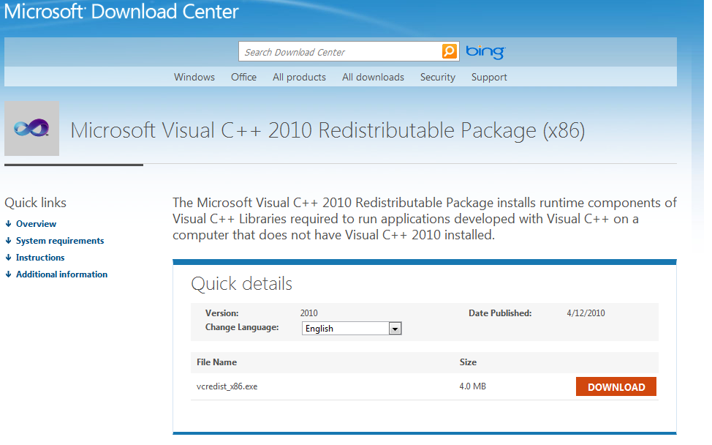

Ensure the language is set to English, and then click the orange Download button. Save the file vcredist_x86.exe to your computer and then double click the vcredist_x86.exe file to start the installer. You will be presented with the following screen:

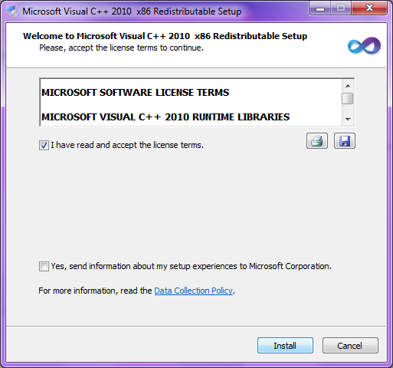

Read the software license terms and confirm your agreement by checking the corresponding check box. Click the Install button.
Once the installation is complete you will see the following page. Click the Finish button to close the installation wizard:
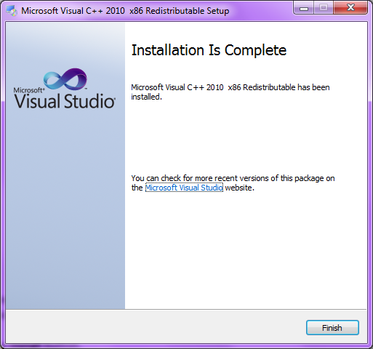

Logging in

In order to use the AVC-BT Admin software you must first log in to the AVC-BT task experiment website. The login page can be found at: http://glctask.webapp3.uea.ac.uk/admin/login.php.

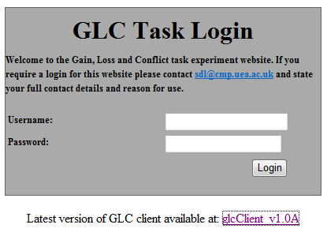

In order to log in to the website and create your own experimental account/team, you will need to be given a username and password. To do this, click on the email address link on the log in page and it will open a window to allow you to type an email to the chief administrator stating your contact details and reason for use. Once sent, you will then be authorised with a username and password that you can change later on if you wish.
If you forget your username and/or password please email the chief administer using this email address link and they will issue you with a new username/password. You may again change these if you wish.
Once you have your username and password, enter them in to the relevant boxes and click the login button. Please note that passwords are case sensitive.

Defining Gain/Loss Schedules

You will now have your own experimental account/team which is a blank canvas for you to add new schedules to in order to build your experiment. To begin creating your experiment you must define the gain/loss schedules that you wish the participant to perform in the experiment. Principally the gain/Loss schedule defines the gain/loss button values presented to the participant during each trial.
3.1 Instructions for new users/ Creating new schedules.
If you are using this software for the first time or wish to create your own schedules then click on the “Manage Schedules " section in the navigation panel on the left of the screen, or alternatively navigate your browser to: http://glctask.webapp3.uea.ac.uk/admin/scheduleEditor.php
Then focus on the “Add New Schedule” section, which is shown below:
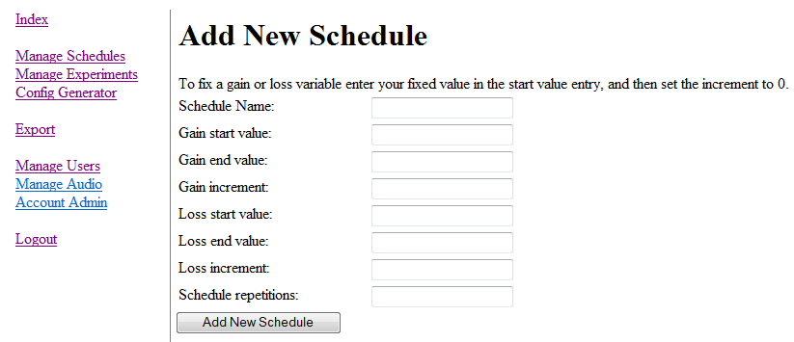

Click on the “Manage Schedules” section.

To provide maximum flexibility, each schedule is defined with the following parameters:
Parameter | Description
Gain Start Value | The gain buttons initial value presented to the participant
Gain End Value | The gain buttons final value presented to the participant
Gain Increment | By how much should the gain buttons value increment after each run?
Loss Start Value | The loss buttons initial value presented to the participant
Loss End Value | The loss buttons final value presented to the participant
Loss Increment | By how much should the loss buttons value increment after each run
Schedule Repetitions | How many times should each Gain/Loss value be repeated?

With the above information predefined, at runtime it is translated to determine the number of runs and what gain/loss values to show the participant. For example, should we have a 'Gain start value' of 20 and a 'Gain end value' of 60 and a 'Gain Increment' of 10, the following sequential Gain button values will be presented to the participant: 20, 30, 40, 50, 60.
In many scenarios, it is desired that either the Gain or Loss button values remain fixed. In order to accomplish this, one must simply set the starting value to the desired fixed constant, and the increment to 0. This will be translated as a fixed value at runtime.
Note that under this system, it is essential that either; one schedule remains fixed OR, that the chosen gain and loss values result in the same number of runs for both gain and loss sequences presented to the participant. When constructing a schedule, the website will forbid you from creating a schedule that will result in non-equal button values from being presented.
When you create an experiment, the start values for each schedule have to be the same. This is to ensure that the experiment data can be comparable once it is exported for analysis. For example, if you have one schedule that is ascending 0→100 and another that is descending 100→0, you would need to ensure that the start value for both schedules was ‘0’. In order to create a descending schedule which ensures this, you enter your values as 0→100 but you select the descending schedule option in the ‘Manage Experiments’ section of the website to make it descend from 100→0. (See page 20).
It is vital to name your schedule something that will be clear and easy to keep track of, especially if you have a number of different schedules saved in your account/team.
During the participant’s trial, they will be presented with 2 consecutive gain/loss schedules. As an example creation of a schedule, we will create 2 schedules with the following parameters:
Test Schedule 1:
Field Name | Value
Schedule Name | Test Schedule 1 - Fixed Loss Variable Gain
Gain Start Value | 0
Gain End Value | 100
Gain Increment | 10
Loss Start Value | 50
Loss End Value | 50
Loss Increment | 0
Schedule Repetitions | 2

Test Schedule 2:
Field Name | Value
Schedule Name | Test Schedule 2 - Fixed Gain Variable Loss
Gain Start Value | 50
Gain End Value | 50
Gain Increment | 0
Loss Start Value | 0
Loss End Value | 100
Loss Increment | 10
Schedule Repetitions | 2

You can use these parameters as an example to practise creating and adding new schedules to the system with. Note that the loss start value in Test Schedule 2 is ‘0’ and the end value is ‘100’. This schedule will be presented as descending from 100→0 once you select the descending schedule order option for that schedule in the ‘Manage Experiments’ section (See page 20).
Once you have finished creating your schedule, click the “Add new schedule” button at the bottom.

Press "Add New Schedule" to submit the new schedule.

3.2 Instructions to modify existing gain/loss schedules on your account.
To modify gain/loss schedules, again click on the "Manage Schedules" section in the navigation panel on the left of the screen, or alternatively navigate your browser to: http://glctask.webapp3.uea.ac.uk/admin/scheduleEditor.php
Focus on the section named “Schedule Editor” (shown below). Here you can choose from a number of preloaded schedules that have already been created for ease of use, or from the schedules you have created previously. When you select a schedule to modify it will show you all the specified options within that schedule in the boxes below. You can leave these options as they are or modify them to suit your experiment. Click on the “Update Schedule” button once finished.
You can also delete any of the preloaded schedules by focussing on the bottom section of the page “Schedule Manager”. Simply select the schedule name you wish to delete and click the “Delete Schedule” button.
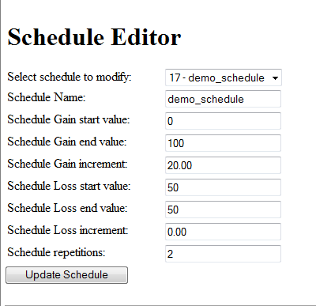
Click the drop down box to select a preloaded schedule.

Create an Experiment

The final step in the 'setup' phase is to create an experiment that uses your predefined gain/loss schedules. To create a new experiment click on "Manage Experiments" in the navigation panel on the left of the screen, or alternatively navigate your browser to the experiment management page found at: http://glctask.webapp3.uea.ac.uk/admin/experimentManagement.php
Click on "Add New" to load the new experiment form. This form allows you to create an experiment which you will use to assign configurations to participants.

Below is a list of configurable values and their respective functions:
Value | Function
Auto Experiment Name | Unique user defined name for the experiment (useful for referencing it later).
Max Trial Run Duration (Seconds) | Defines the duration that the gain and loss buttons are presented to the participant for each trial run.
Intermission Duration (Seconds) | Currently unimplemented. However is intended if required set an intermission duration between consecutive trial runs
Button Min Delay (Seconds) | The minimum amount of time it takes for the buttons to be presented to the participant once they depress the X button
Button Max Delay (Seconds) | The maximum amount of time it takes for the buttons to be presented to the participant once they depress the X button.
Money Pot Start Value | The starting value of the subjects 'Money Pot'.
Money pot String Format | The string format for the 'Money Pot'. This allows for custom monetary representations such as £ or $. Note that the string is formatted as such:  "<string> %s" where %s denotes where the score is to be inserted. For example "£ %s" would result in (for a score of 50) "£ 50".
Gain Sound File | The audio file that will be played when the participant hits the gain button.
Loss Sound File | The audio file that will be played when the participant hits the loss button
White Noise Sound File | The audio file that will be continuously played on repeat in the background. (Intended for white noise).
Gain Colour | The colour of the gain button stored in hexadecimal format
Loss Colour | The colour of the loss button stored in hexadecimal format
Trial Schedule 1: Loss/Gain Schedule | The first loss schedule that the participant will be presented with.
Trial Schedule 1: Schedule Order | This adjusts the order in which the schedule 1 values are presented. They can be: Server Assigned or Fixed(Ascending / Descending / Random)
Trial Schedule 1: Button Location | This adjusts where the gain button is located during schedule 1. This can be: Server Assigned or Fixed (Left / Right / Random)
Trial Schedule 2: Loss/Gain Schedule | The second loss schedule that the participant will be presented with.
Trial Schedule 2: Schedule Order | This adjusts the order in which the schedule 2 values are presented. They can be: Server Assigned or Fixed(Ascending / Descending / Random)
Trial Schedule 2: Button Location | This adjusts where the gain button is located during schedule 2. This can be: Server Assigned or Fixed (Left / Right / Random)

Specifying the schedule order or button location as Server Assigned will force the server to choose one of the fixed options during Config generation. The server will assign these values to the configurations in a manner which produces an even distribution of results across the gain/loss schedule.
Specifying the schedule order as Descending will reverse the original (ascending) schedule order. This option is to be used when you want to create a descending schedule, as you still must make sure that your start value is the same as the other schedules in your experiment.
Specifying the schedule ordering as Random will generate a random presentation of the original ascending schedule order of values to the participant, for example if your schedule order goes from 0→50 in increments of 10, a random presentation may be displayed as: 20, 40, 10, 50, 0, 30.

The figure below shows you the experiment form that you see when you add a new automated experiment. Note the red arrows which show you where to select and change the schedule order to Ascending, Descending, and Random.

Press on "Submit New Experiment" to create the experiment.
- Generate a Configuration
Once an experiment has been created using the predefined gain/loss schedules you can proceed to generate a configuration for a participant.
Click on "Config Generator" in the navigation pane on the left of the screen. This should redirect you to: http://glctask.webapp3.uea.ac.uk/admin/configGenerator.php
Click on the "Generate User Configuration for experiment" button. This will allow you to create a configuration for an experiment.

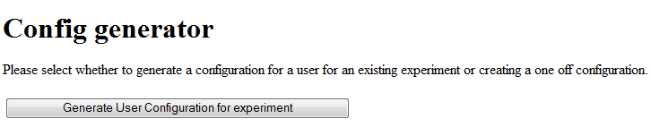

You will then be presented with simple onscreen instructions. Firstly you must select the participant you are creating the configuration for. In this guide we will assume no users have been created and we desire to add a new user. Thus Check the "New User" check box and enter a user name in for the participant. User names are required to be all 1 word, and not contain any special characters such as '#~. In order to be able to refer back to each participant’s data once it has been collected in a database, you must enter every participant as a “new user”, with a unique id. As is clearly seen, you can also generate a configuration for an existing user by selecting them from the "Existing User" drop down box (and making sure "New user" is unchecked).

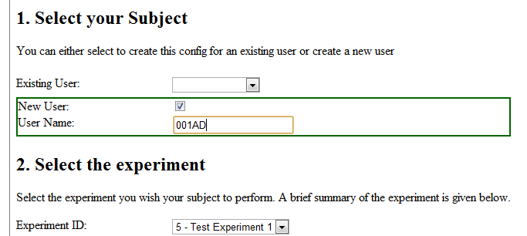

Next, under the heading: "2. Select the experiment" select the experiment we previously created. You can briefly review all of the parameters that will be assigned to the participant once the experiment has been selected.
Once you have reviewed the parameters, press on "Generate Configuration" and the server will generate a configuration in a .zip file for you with the gain/loss schedules, audio files and other settings defined in the experiment.

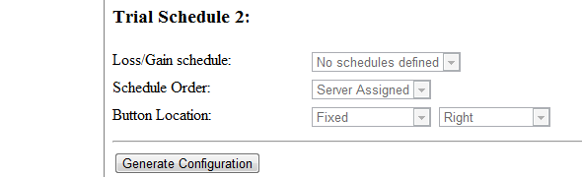
When requested to save/download the file, do so to a temporary location e.g. your desktop. Make a note of the name of this .zip file.

Install AVC-BT Client Application, Copy the Configuration into the “Config” Folder and Load the AVC-BT Client Setup Screen.

  - Installing the Application
Download the AVC-BT client application (which contains a folder called “Conflict” and many smaller folders and files) from the AVC-BT task experiment website by clicking on the link “glcClient v1.0A” either on the AVC-BT Task Login page here:

Or on the Index page here:
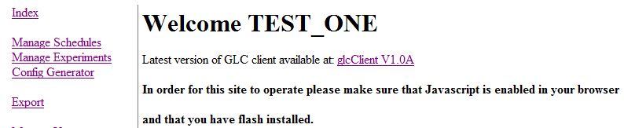
Save this application folder to an easy –to-find location on your computer’s hard drive e.g. the desktop.
To install the application, click and open the saved “glcClient” folder. Then extract the “Conflict” folder contained in the .zip file to an easy-to-find location on the computer’s hard drive e.g. the desktop. To do this you click on the “Extract” icon above the “Conflict” folder and choose a destination to copy the folder to.

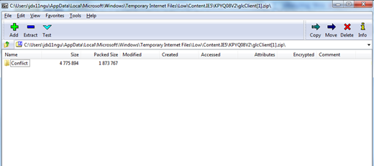
Once this is done, find the destination where you copied the extracted “Conflict” folder to and click to open it.

  - Installing the Experiment Configuration zip File
Copy the downloaded experiment configuration zip file from your download location into the glcClient's “Config” folder (which is within the “Conflict” folder).There is no need to extract the files contained in the .zip file; the application will do this automatically.
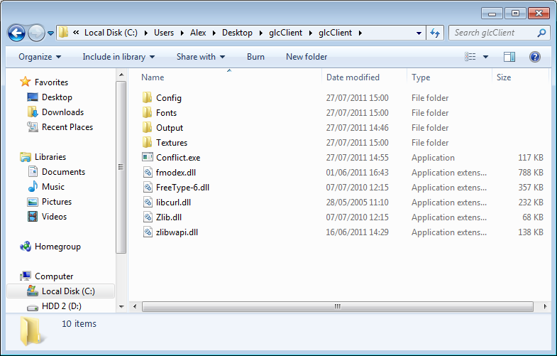
Run the experiment by clicking on this Conflict application.
Copy the zip file into the Config folder.

This marks the completion of generating a configuration file.
  - Running the Experiment
Finally, run the AVC-BT Client software (by clicking on the “Conflict” application) and the latest generated configuration file (your named .zip file) in the “Config” folder will automatically be loaded onto the experimenter setup screen, as shown below:
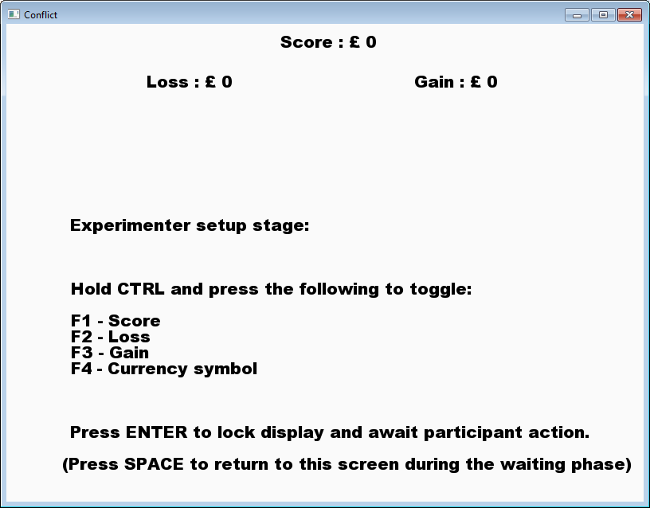

Summarizing Notes

Now that you have defined gain/loss schedules, audio files and an experiment on your account it is very easy to generate multiple configurations for an experiment. To generate a new configuration file for a new or existing user simply follow this guide from Step 5: “Generate a Configuration”.

User Manual Part 2- AVC-BT Experiment Client Application User Guide
Contents
1. Running the Experiment....................................................................................................25
1.1 Experimenter Setup Stage and Waiting Screen.................................................................26
1.2 The Practice Session...........................................................................................................27
1.3 Playing the Experiment......................................................................................................27
1.4 Clicking the Buttons / Timer Operation.............................................................................28
1.5 Scoring...............................................................................................................................28
1.6 Finishing the Experiment and exporting data...................................................................28

2. Uploading the Audio Files..................................................................................................29

3. Calibrating the Volume......................................................................................................31

4. Troubleshooting................................................................................................................31
4.1 Configuration Not Found...................................................................................................31
4.2 Font Error...........................................................................................................................31
4.3 Invalid Gain/Loss Settings..................................................................................................32
4.4 Results Upload Failed.........................................................................................................32
4.5 Schedule/Run Error............................................................................................................33
  - Sound Too Short...............................................................................................................33
  - Texture Error.....................................................................................................................33
4.8 The Wrong Configuration File is Loaded............................................................................34

5. Glossary of Result Information in Results Export Databases.............................................34
5.1 All data...............................................................................................................................34
5.2 Results per Schedule..........................................................................................................37

6. Written Instructions for the Experiment Participants.......................................................39
6.1 Written Instructions for the gaining/losing of money.......................................................39
6.1 Written Instructions for the gaining/losing of points........................................................40

1. Running the Experiment
Once you have become familiar with the ‘User Manual-Part 1’ and have carried out the instructions and examples in it successfully, you will then move on to using the AVC-BT Client Application (the application that the experimental task runs on). This guide will run through the stages of the Approach, Avoidance and Conflict Behavioural Task experiment.

1.1 Experimenter Setup Stage and Waiting Screen:
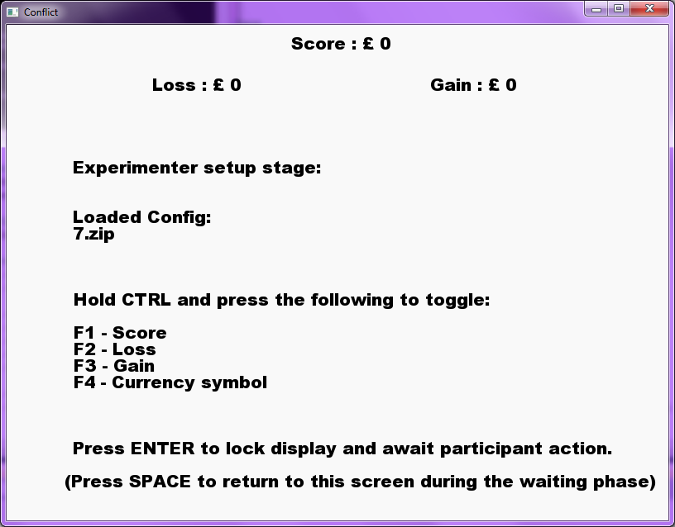

This screen allows experimenters to toggle various components of the display that will be visible to the participants. By holding CTRL and pressing F1/F2/F3/F4, the score/loss/gain/currency symbol can be toggled on or off. Note that the display symbols are not shown during the practice schedule.
This screen also displays the name of the loaded configuration file; check that this is the correct file before running.
Once the options are set, press the ENTER key to lock the display settings and advance to the next screen.
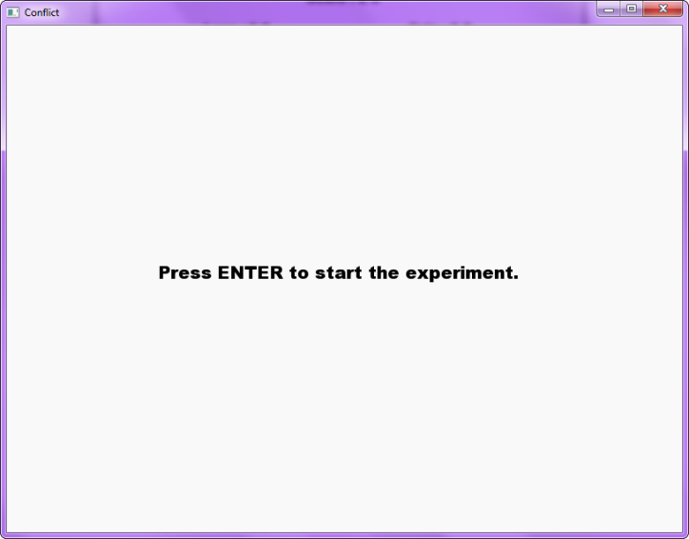

Once the display options have been locked, participants are presented with the waiting screen. During this time, experimenters can press the SPACE key to return to the setup screen for any further adjustments.
Once a participant is ready, pressing the ENTER key will begin the experiment.

1.2 The Practice session
The first section common to all experiments is the practice session. Participants are presented with the circular money/points buttons, one of which is marked with an “X” symbol.
Participants are instructed to perform 5 repeats of clicking the right circle and then 5 of clicking the left.
If the participant clicks the wrong circle, does not click at all, clicks too late, or releases the ‘X’ button too early, they are required to repeat the attempt up to a maximum of 10 times. After the 10th failed attempt they are shown a message onscreen stating that they have not understood the practice task correctly.
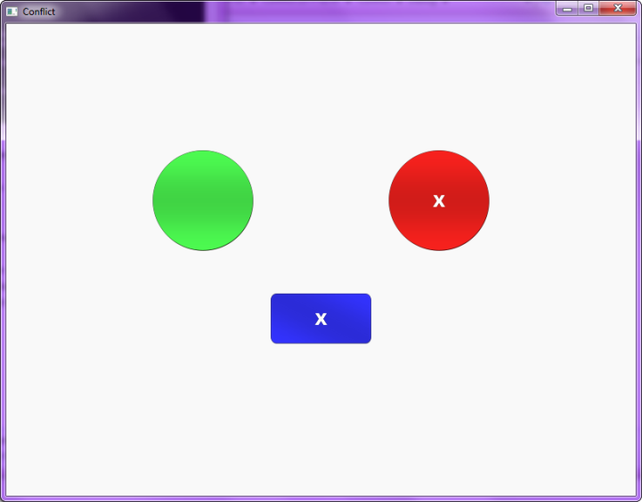

The following data is collected for the Practice session attempts:
- Decision time (ms)
- Movement time (ms)
- Mouse click location
- Result status flag
- Gain button location
- Button delay (ms)
- Mouse path
- Root mean squared deviation of mouse

1.3 Playing the Experiment
At the beginning of each attempt the participant is presented with a blue rectangular button marked with an “X”. This button is termed the start button.

1.4 Clicking the Buttons / Timer Operation
Once the start button is pressed, the mouse sampling process begins. The start button must be held down until the circular money/points buttons appear. The money/points buttons appear after the button delay has expired.
If the participant releases the start button before this time has expired, the attempt is regarded as a failure and must be repeated.
Once the money/points buttons appear on the screen, the decision timer is started. This records the time from the buttons appearing, to the time that the participant releases the start button.
Once the start button is released, the movement timer records the time from this point until one of the money/points buttons is clicked.
Once the money/points buttons have appeared, the participant has a limited amount of time to react. This time limit is specified by the maximum response time. If neither money/points button is pressed within this time limit, the attempt is recorded as a failure and must be repeated. As with the practice session, a failed attempt can be repeated up to 10 times. Result statistics are recorded for all attempts whether successful or not.

1.5 Scoring
The participant’s score is updated according to which money button is clicked.
If the gain button is pressed, the participant’s score is incremented by the amount indicated on the gain button. The score is simultaneously decremented by the amount associated with the loss button.
If the loss button is pressed, the score is neither incremented nor decremented. The loss button effectively prevents the loss indicated by its current value.

1.6 Finishing the Experiment and exporting data
Once an attempt has been successfully completed, the next attempt is presented to the participant. Once all runs of a given schedule have been completed, the participant is informed that the next schedule is about to begin.
Once all schedules have been completed, the results are automatically uploaded to the server. Should the uploading process fail, a message informs the participant that the results file must be uploaded manually (see section 2.4 for details). To access each participant’s results data, click on “Export” section in the navigation pane on the left of the screen.

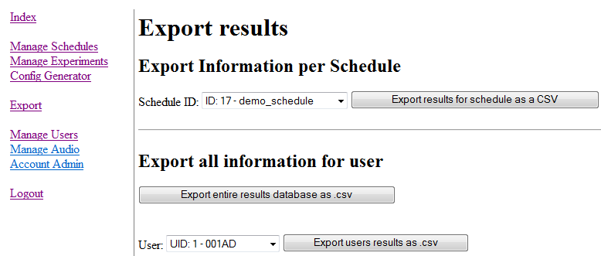
3.
2.
1.

If you wish to export the data for each separate schedule and wish to view and compare how all of the individual participants/users who have completed that schedule have performed, then click on the top button numbered 1: “Export results for schedule as a CSV”. This export option is more suited to those who wish to conduct statistical analyses on their data, especially in SPSS. However, this export option only gives the most relevant data so you will need to refer back to the “Manage Schedules/Schedule Editor” section of the website if you wish to view the specific parameters defined for that schedule. It also does not give any information on the practise trials.
If you wish to export the data from all the schedules that an individual user/participant has completed then click on the bottom button numbered 2: “Export users results as. csv”. First though, you must click on the drop-down box on the left, next to the word ‘User’ to specify your chosen participant/user. This option does give information on the practise trials.
You can also export the data for all your participants/users at once by clicking on the middle button numbered 3: “Export entire results database as .csv”.
To see a full glossary of how to interpret the results export databases, go to section: 5. Glossary of Result Information in Results Export Databases.

Uploading Audio Files

For ease of use, the AVC-BT Client software comes with optional preloaded audio files that can be used in the configurations and played to the participants. These audio files are used during the experiment for the Gain button and Loss button click events, as well as the background noise.
If you wish to upload your own audio files then use the following instructions:
In order to upload your own audio files, you will need to provide sound files for the following 3 events (Examples are provided in the enclosed Default Sound Files folder):
- Gain button pressed
- Loss button pressed
- background noise (e.g. whitenoise)
Audio files must be provided in .mp3 format and any audio file used for background audio must be loop-able.
To upload your audio files click on "Manage Audio" in the navigation pane or alternatively, navigate your browser to: http://glctask.webapp3.uea.ac.uk/admin/audioManagement.php

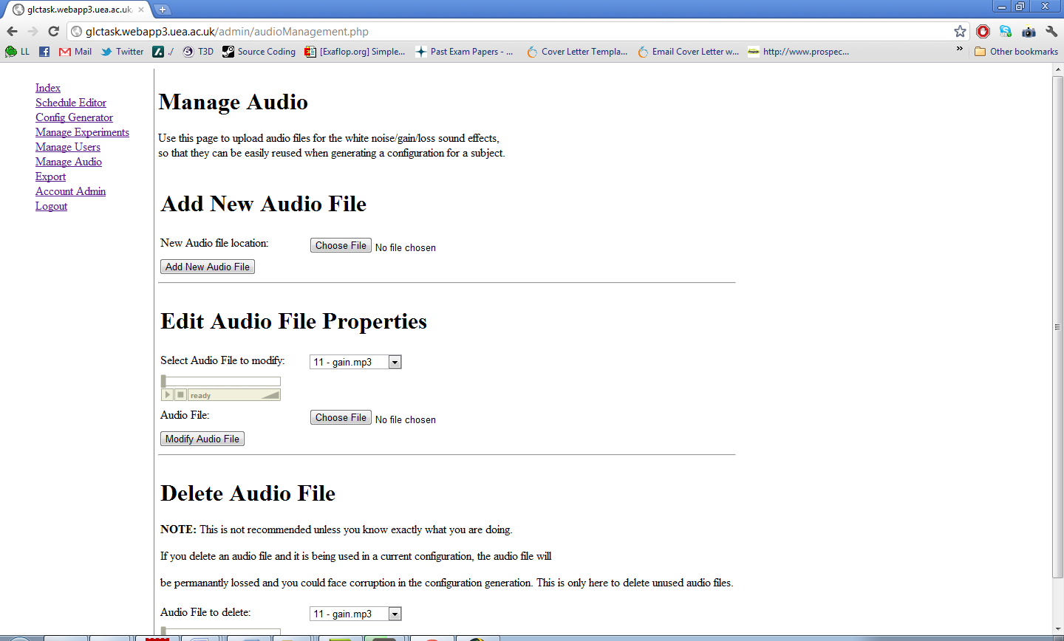

Under the "Add New Audio File" heading select "Choose File" and navigate to the chosen mp3 you wish to upload.
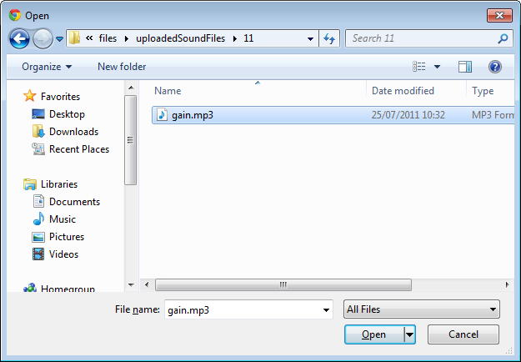

Click "Open" to select the mp3 file you wish to upload and then press "Add New Audio File" on the html form to initiate the audio file upload to the server.
You can then preview your uploaded audio files, under the "Edit Audio file Properties" with the flash audio player.

Preview audio file here

Repeat this process until you have uploaded 3 audio files you wish to use for the Gain button and Loss button click events, as well as the background noise.

- 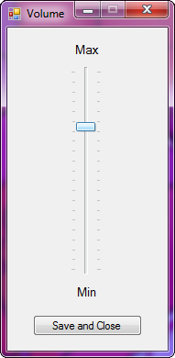Calibrating the Volume
To set the volume level for the experiment, locate and run “VolumeConfig.exe” located in the “Config” directory.
Move the volume slider to the desired level and click “Save and Close” to save the volume settings.

4. Troubleshooting
4.1 Configuration Not Found
Message: No configuration files found.
Zipped configuration files must be placed in the following directory: \...\Conflict\Config\
Solution: This error occurs when the experiment application is started before any configuration files are installed. See section 1.2 for how to install downloaded configuration files into the directory specified by the error message (\...\Conflict\Config\).
4.2 Font Error
Message: Error Loading Font “font_name”.
Solution: Ensure the fonts “ariblk.ttf” and “lucon.ttf” are in the \Conflict\Fonts\ directory.

4.3 Invalid Gain/Loss Settings
Message: An error has occurred due to invalid gain/loss settings for trial x…
Solution: This error occurs when both the gain and loss values vary throughout a schedule (i.e. neither the gain nor loss is fixed). The number of runs generated from the gain and loss settings must be equal.
For example:
Setting the gain values as follows:
Gain start value: 0
Gain end value: 100
Gain increment: 10
Will generate 11 runs (0, 10, 20, 30, 40, 50, 60, 70, 80, 90, 100).
Whilst setting the loss values as follows:
Loss start value: 100
Loss end value: 0
Loss increment: 20
Will generate only 6 runs (100, 80, 60, 40, 20, 0).
The number of runs generated from both the gain and loss values must be equal. A valid set of loss values would therefore be:
Loss start value: 100
Loss end value: 0
Loss increment: 10
Which will also generate 11 runs which equals the number of runs calculated from the gain values.

4.4 Results Upload Failed
If the automatic results upload process fails, the results file can be uploaded manually. Locate the results text file in the \Conflict\Output\ directory. Each results file is named after the participant’s user ID and the date of the experiment.
Results can be uploaded manually from the following web page: http://glctask.webapp3.uea.ac.uk/submitResults.php

  - Schedule/Run Error
Messages:
1. This experiment contains less than 2 Schedules.
Valid experiments must contain least 2 Schedules.
Please provide a valid experiment configuration and restart the application.
2. Run “x” of Schedule “y” has 0 Repeats.
Valid Runs must contain at least 1 Repeat.
Please provide a valid experiment configuration and restart the application.
Solution: Ensure the experiment generated from the website has 2 schedules and that each schedule has at least 1 repeat.
Amend the experiment configuration settings and download a new configuration file.

4.6 Sound Too Short
Message: The supplied noise sound is not long enough.
The sound must be at least 500ms.

Solution: Sound files used to play the background noise must be at least 0.5s in length. To fix this error upload an mp3 file of at least 0.5s to the website and download a new configuration.

4.7 Texture Error
Message: texture_x.tga could not be found.
Solution: Ensure the files “moneyButton.tga”, “startButton.tga” and “startButtonPressed.tga” are in the \Conflict\Textures\ directory.

4.8 The Wrong Configuration File is Loaded
The experiment application loads the newest configuration file found in the \Conflict \Config\ directory. If the wrong configuration is being loaded, remove all .zip configuration files other than the desired configuration from the \Conflict\Config\ directory.

5. Glossary of Result Information in Results Export Databases

All data- see table option 2 from page 29
Data result label | Description
User ID | Unique identifier for subject
User Name | User name assigned to subject by the researcher
Team ID | The team the subject belongs to
Team Name | The team name the subject belongs to
Team Email Address | The team’s email address
Team Phone Number | The team’s contact phone number
Team Address Line 1 | The team’s address line 1
Team Address Line 2 | The team’s address line 2
Team Address Line 3 | The team’s address line 3
Team Country | The country that the team operates from
Experiment ID | Unique experiment identifier (The ID of the experiment that the subject was participating in)
Experiment Auto ID | The name assigned to the experiment by the researcher
Experiment Max Trial Duration | Defines the duration that the gain and loss buttons are presented to the subject for each trial run.
Experiment Intermission Duration | The intermission duration assigned for this run. It can be used if you are required set an intermission duration between consecutive trial runs
Experiment Minimum Button Delay | The minimum amount of time it takes for the buttons to be presented to the subject once they depress the X button
Experiment Maximum Button Delay | The maximum amount of time it takes for the buttons to be presented to the subject once they depress the X button.
Experiment Gain Button Sound ID | The unique identifier for the sound file that is played when the gain button is clicked.
Experiment Gain Button Sound Name | The sound file name for the gain button
Experiment Loss Button Sound ID | The ID of the loss buttons sound file for this run The unique identifier for the sound file that is played with the loss button is clicked.
Experiment Loss Button Sound Name | The sound file name for the loss button
Experiment White Noise Button Sound ID | The unique identifier for the sound file that is played for background white noise.
Experiment White Noise Button Sound Name | The sound file name for the white noise
Experiment Gain Button Colour | The colour of the gain button assigned for this run
Experiment Loss Button Colour | The colour of the loss button assigned for this run
Experiment Schedule 1 ID | The unique identifier for the first loss/gain schedule that the subject plays through
Experiment Schedule 1 Order | The order that the first loss/gain schedule is conducted in. Either Ascending/Descending or Quasi Random
Experiment Schedule 1 Button Location | The location of GAIN button for the first loss/gain schedule. (Note the Loss buttons location is implicitly assigned dependant on the gain buttons location). Accepts either Ascending/Descending or Quasi Random
Experiment Schedule 2 ID | The unique identifier for the second loss/gain schedule that the subject plays through.
Experiment Schedule 2 Order | Defines the order that the schedule is presented in for the second loss/gain schedule that the subject plays through.
Experiment Schedule 2 Button Location | The location of the GAIN button for the second loss/gain schedule.
Result ID | The ID for the set of trial runs that were submitted
Trial Run Result ID | Unique identifier for this trial run
Trial Schedule ID | The schedule ID shows which schedule the subject was executing during this trial run
Trial schedule name | The name of the schedule the subject executed during this run
Trial Schedule Gain Button Start Value | The starting gain value for the schedule the subject executed during this run
Trial Schedule Gain Button End Value | The final gain value for the schedule the subject executed during this run
Trial Schedule Gain Button Increment | The increment for the gain button for the schedule the subject executed during this run
Trial Schedule Loss Button Start Value | The starting loss value for the schedule the subject executed during this run
Trial Schedule Loss Button End Value | The final loss value for the schedule the subject executed during this run
Trial Schedule Loss Button Increment | The increment for the loss button for the schedule the subject executed during this run
Trial Schedule Repetitions | Specifies how many repetitions the user performed as part of this run
Trial Number | Specifies when this schedule was presented to the subject during the whole trial: 0 = during practice, 1 =during trial schedule 1, 2 =during trial schedule 2.
Trial Score | The score for this schedule in the ‘result ID’ set of uploaded results.
Date Submitted | The date the result was submitted
Mouse Sampling Rate | The mouse sampling rate that the mouse was recorded at for this result
Gain Button Value | The value of the gain button being presented to the subject
Loss Button Value | The value of the loss button being presented to the subject
Repetition Number | The repetition index for the trial runs. If the schedule has 5 repetitions for each run, you would expect this value to go from 0->4 (0 based). If Repetition Number>5 you know the subject has failed one of the trials. Look at ‘Status Flag’ to determine which trial runs were failed.
Mouse Path String | The mouse path that the subject took is sampled at a rate defined by the ‘Mouse Sampling Rate’. Each sample in the mouse path string is defined by three values: x coordinate, y coordinate and a number defining the state of the mouse. Each sample is separated by a semi-colon in the path string. The following numbers represent the state of the mouse when the sample was taken. Left mouse button is up = 1,  Left mouse is just released = 2,  Left mouse button is just pressed = 3,  Left mouse button is down = 4,  e.g. 2, 3, 4; 2, 6, 2 ; In this case the mouse starts at 2,3 with the button down and then it moves vertically to 2,6 when the user releases the mouse button.
Decision Time | The time from when the money buttons appear (i.e. when  the button timer has expired) to when the subject releases the x/start  button.
Movement Time | The time taken from the end of the decision time, i.e. when subject releases the x/ start button, to when the subject clicks one of the gain/loss buttons.
Generated Delay | The button presentation delay generated for this trial run. (AKA the time taken for the button to appear).
Button Hit Location X | The subject’s X coordinate hit location on the hit button/ The X component of the hit location of the button relative to the buttons origin
Button Hit Location Y | The subject’s Y coordinate hit location on the hit button/ The Y component of the hit location of the button relative to the buttons origin
Status Flag | The status flag for a trial run. The result of the trial can be one of seven options:  1: - attempt was a success, hit gain button (correct decision)  2: - attempt was a success, hit gain button (incorrect decision)  3: - attempt was a success, hit loss button (correct decision)  4: - attempt was a success, hit loss button (incorrect decision)  5: - attempt failed, user released start button too early  6: - attempt failed, max response timer expired during decision time/start button was not released  7: - attempt failed, max response timer expired during movement time/ no click once release of start button/clicked elsewhere other than on gain or loss button
Gain On Left | Specifies if the gain button was on the left for this run (1= Gain on left).

Results per Schedule- see table option 1 from page 29
Data result label | Description
User ID | Unique identifier for the subject
Experiment ID | The name given to the experiment by the researcher
Schedule Order | Defines the order that the loss/gain schedule is presented in. Can be either Ascending, Descending or Quasi Random
Gain Button Location | Location of the gain button on screen in the experiment
T# Movement Time | The time taken from when the user releases the x/start button to when they click a money/points button.
T# Decision Time | The time from when the money/points buttons appear on screen (i.e. when the button timer has expired) to when the user releases the x/start button.
T# Generated Presentation Delay | The button presentation delay generated for this trial run. (AKA the time taken for the money/points button to appear on screen).
T# RMSE | Root mean square error of the mouse path from the shortest line between the start and end. (see below)
T# Result | Error codes are displayed with the following meanings:  FAIL_PREM_RELEASE - attempt failed, user released start button early  FAIL_RESP_TIMEOUT_DEC - attempt failed, max response timer expired during decision time/ start button was not released  FAIL_RESP_TIMEOUT_MOV - attempt failed, max response timer expired during movement time/ no click once release of start button/clicked elsewhere other than on gain or loss button  These error codes are listed in the following format: Number of Errors; Error1, Error2, e.g. 2; FAIL_PREM_RELEASE, FAIL_PREM_RELEASE.

The’ #’ after the ‘T’ refers to the trial that is presented to the user (the specific trial number).
When you create an experiment, the start values (labelled T1) for each schedule have to be the same. This is to ensure that the experiment data can be comparable once it is exported for analysis. For example, if you have one schedule that is ascending from 0→100 and another that is descending from 100→0, you would need to ensure that the start value (T1) for both schedules was ‘0’.
The exported results for the trials are exported in the order given by the schedule. For example if the schedule's gain value starts at 0 then T1 in the exported results will refer to the trial when the gain value was 0. Although during the set up of your experiment you can change the schedule order of the trials to ascending, descending or random, the trials will always be presented in the same order as one another once they are exported for comparison and analysis. This is because they resume the original order that was initially specified when the schedules were created in the ‘Manage Schedules’ section (and you ensured that the start values were all the same at that stage). ‘

6. Written Instructions for Experiment Participants
These standardised written instructions can be given to all participants before they begin the Approach, Avoidance and Conflict Behavioural Task experiment. There are two sets of instructions, one for the gaining/losing of money, and one for the gaining/losing of points.

6.1 Written instructions for the gaining/losing of money.

Instructions for Behavioural Task
Today you will be taking part in a study that looks at the way in which people make decisions over the gaining or losing of money.

You will be completing a reaction time task on the computer in which you will quickly judge and make decisions about the gaining and losing of money. Your aim is to maximise the amount of money you gain. The entire task should take approximately 30 minutes to complete.

Please read the information sheet on your desk and if you are happy to please read, sign and date the consent form attached. If you have any questions, someone will come and speak with you.

A) Practice session instructions:
On your computer you will see a white screen with instructions on it. The task will begin with a practice session which will get you used to the task. You will not be scored on your performance in this session.

Press the enter button to begin the practice session and please read and follow all instructions on the pop up boxes that appear on screen.

To start the practice session, you will need to left click on the blue rectangle with the ‘X’ in it and hold the mouse button down until 2 circles appear. Once they appear, please quickly move your mouse and click the circle on the right containing the ‘X’. You will practice clicking on the right circle 5 times.

The circles will disappear when you click on them. To continue, left click on the blue rectangle once again and hold the mouse button down until the circles reappear. You will then be asked to click on the left circle 5 times.

Once you have gone through the practice session, a pop up box will tell you that the task is about to begin. If at that stage you have understood the practice and are happy to continue then press OK. If you have any questions, please wait for someone to come and speak with you.

B) Task instructions (PLEASE READ FULLY BEFORE STARTING THE TASK):
At the start of the task you will see a blue rectangle with an ‘X’ in it. As in the practice session, to begin the task you will need to left click and hold your mouse button down on the blue rectangle, until 2 coloured circles appear (one green and one red). This time however, the circles have a specific value of money shown inside them.

Once they appear, you are required to make a decision between choosing to click on either the green or red circle. Your decision is based on maximising the amount of money you gain.
If you click on the green circle (which is called the ‘gain’ button), you will gain the value of the money shown inside it, but will lose the value of the money shown inside the red (loss) circle.

If you click on the red circle (which is called the ‘loss’ button), you will prevent the loss of the money shown inside it, however you will lose the value of the money shown inside the green (gain) circle.

The task has 2 parts and a pop up box will signal when the second part is beginning. Once the task is finished a pop up box with say that your results were uploaded successfully. The task will close once you press the OK button.

You may now start the task, ensuring you have read the instructions above fully.

Once you have finished the task, please read the debriefing form. If you are happy to then please read, sign and date the attached consent form. If you have any questions, please wait for someone to come and speak to you.

Thank you for participating!

6.1 Written instructions for the gaining/losing of points.

Instructions for Behavioural Task
Today you will be taking part in a study that looks at the way in which people make decisions over the gaining or losing of points.

You will be completing a reaction time task on the computer in which you will quickly judge and make decisions about the gaining and losing of points. Your aim is to maximise the amount of points you gain. The entire task should take approximately 30 minutes to complete.

Please read the information sheet on your desk and if you are happy to please read, sign and date the consent form attached. If you have any questions, someone will come and speak with you.

A) Practice session instructions:
On your computer you will see a white screen with instructions on it. The task will begin with a practice session which will get you used to the task. You will not be scored on your performance in this session.

Press the enter button to begin the practice session and please read and follow all instructions on the pop up boxes that appear on screen.

To start the practice session, you will need to left click on the blue rectangle with the ‘X’ in it and hold the mouse button down until 2 circles appear. Once they appear, please quickly move your mouse and click the circle on the right containing the ‘X’. You will practice clicking on the right circle 5 times.

The circles will disappear when you click on them. To continue, left click on the blue rectangle once again and hold the mouse button down until the circles reappear. You will then be asked to click on the left circle 5 times.

Once you have gone through the practice session, a pop up box will tell you that the task is about to begin. If at that stage you have understood the practice and are happy to continue then press OK. If you have any questions, please wait for someone to come and speak with you.

B) Task instructions (PLEASE READ FULLY BEFORE STARTING THE TASK):
At the start of the task you will see a blue rectangle with an ‘X’ in it. As in the practice session, to begin the task you will need to left click and hold your mouse button down on the blue rectangle, until 2 coloured circles appear (one green and one red). This time however, the circles have a specific value of points shown inside them.

Once they appear, you are required to make a decision between choosing to click on either the green or red circle. Your decision is based on maximising the amount of points you gain.
If you click on the green circle (which is called the ‘gain’ button), you will gain the value of the points shown inside it, but will lose the value of the points shown inside the red (loss) circle.

If you click on the red circle (which is called the ‘loss’ button), you will prevent the loss of the points shown inside it, however you will lose the value of the points shown inside the green (gain) circle.

The task has 2 parts and a pop up box will signal when the second part is beginning. Once the task is finished a pop up box with say that your results were uploaded successfully. The task will close once you press the OK button.

You may now start the task, ensuring you have read the instructions above fully.

Once you have finished the task, please read the debriefing form. If you are happy to then please read, sign and date the attached consent form. If you have any questions, please wait for someone to come and speak to you.

Thank you for participating!

