Table 1. Bivariate Correlations and Descriptive Statistics
----------------------------------------------------------------------------------------------------------------------------------------------------------------
Variable 1 2 3 4 5 6 7 8 9 10 11
----------------------------------------------------------------------------------------------------------------------------------------------------------------
Socio-Demographics
- Age
Mood
- General Positive Affect (GPA) -.18
- General Negative Affect (GNA) -.24* .32**
RST-PQ Personality Factors
- Fight-Flight-Freeze System (FFFS) -.23 .06 .34**
- Behavioural Inhibition System (BIS) -.21 .02 .41** .43**
- Reward Interest (BAS-RI) .11 .16 -.04 -.17 -.14
- Goal-Drive Persistence (BAS-GDP) -.05 .10 .10 .02 -.06 .27*
- Reward Reactivity (BAS-RR) -.36** .29** .30** .36** .18 .30** .18
- Impulsivity (BAS-Imp) -.16 .16 .25* .28* .38** .21 -.14 .51**
Economic Preferences
- Risk-Seeking -.02 .17 -.01 -.01 .07 .16 .25* .10 .09
- Delay-Impatience -.27* .03 .06 .29** .05 -.29* .05 .30** .22 .05
Mean 31.73 20.44 17.63 22.45 59.12 19.74 20.51 28.35 19.95 5.41 3.13
SD 7.77 7.31 6.48 6.21 14.24 3.84 4.49 5.38 4.46 2.59 2.52
Range 38 28 29 25 68 20 19 22 20 11 7
Cronbach’s Alpha - .85 .80 .77 .93 .85 .77 .86 .73
----------------------------------------------------------------------------------------------------------------------------------------------------------------
Note. N = 78. *p < .05, **p < .01.

Figure 1. Flow of the experiment

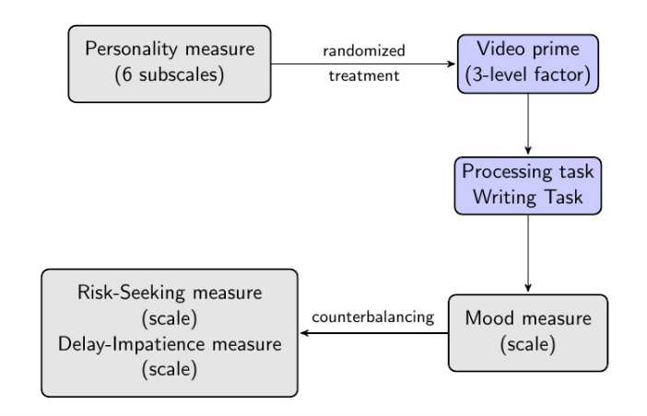

Figure 2. Mean Risk-Seeking (error bars +/- 2 SEs) for Low and High (median split) BAS-Imp, by Threat Condition

Figure 3. Mean Delay-Impatience (error bars +/- 2 SEs) for Low and High (median split) BAS-GDP, by Threat Condition

