Supplemental materials

Table 1. Set correlation analysis showing partial correlations between the BAS scales and the Mini-K subscales (male participants)
 | Reward  Interest | Goal-Drive  Persistence | Reward  Reactivity | Impulsivity | SR
Age | -.12 | -.12 | -.21* | -.04 | -.27**
Insight, planning, and control | .44** | .53** | .31** | .18* | .18*
Mother/father relationship quality | -.09 | -.02 | .04 | .01 | -.06
Experience in close  relationships | -.12 | -.01 | .00 | -.02 | -.21*
Family social contact and support | -.02 | -.05 | -.09 | -.01 | -.20*
Friends social contact and support | .20* | .03 | .19* | .08 | .02
Engagement in community | .10 | .13 | .05 | .05 | .13**
R | .55 | .59 | .48 | .23 | .44
R² | .31 | .35 | .23 | .06 | .19
F(7, 165) | 1.38* | 12.77* | 7.03* | 1.36** | 5.65*
Cohen set correlation R²= .58, F(35, 650.25) = 4.22
*p<.01, **p<.05

Table 2. Set correlation analysis showing partial correlations between the BAS scales and the Mini-K subscales (female participants)
 | Reward  Interest | Goal-Drive  Persistence | Reward  Reactivity | Impulsivity | SR
Age | .09 | -.06 | -.01 | -.12* | -.28*
Insight, planning, and control | .37** | .51** | .19* | .03 | .13*
Mother/father relationship quality | .01 | -.04 | .05 | .05 | .02
Experience in close relationships | -.10 | .09 | .09 | -.03 | -.11*
Family social contact and support | -.02 | .05 | .08 | -.01 | -.03
Friends social contact and support | .18** | .01 | .23** | .13 | -.15*
Engagement in community | .11 | .04 | -.04 | .08 | .08
R | .47 | .58 | .47 | .23 | .29
R² | .22 | .33 | .22 | .05 | .09
F(7, 276) | 11.26* | 19.79* | 11.21* | 2.15** | 3.68*
Cohen set correlation R²= .56, F(35, 1117.18) = 6.97
*- p<.01; **- p<.05

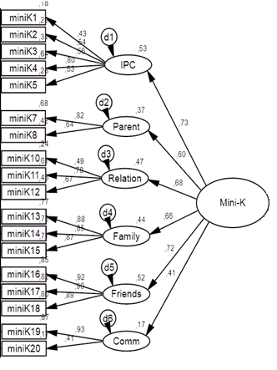

Figure 1. Since this was the first application of Croatian translation of the Mini-K, we examined its construct validity. A one-dimensional model did not achieve the minimal goodness of fit indices according to Hu and Bentler (1999); χ²/df between 2 and 5, CFI above .95, and RMSEA and SRMR below .08. However, the hierarchical model presented on the left side of the Figure 1 achieved acceptable model fit indices: χ² (113) = 367.90, χ²/df=2.85, CFI = .927, RMSEA = .064, SRMR = .061. Error covariances were not added in the model. Thus, the results from the Mini-K can be used as a general score, which represents the composite variable of a set of subscales, and enables the analysis on general and specific domain level. The subscales are labelled according to ALHB (Figueredo, 2007): Insight, planning, and control (e.g. “I often find the bright side to a bad situation.”), Mother/father relationship quality (e.g. “While growing up, I had a close and warm relationship with my biological mother.”), Experience in close relationships (e.g. “I have a close and warm romantic relationship with my sexual partner.”); Family social contact and support (e.g. “I am often in social contact with my blood relatives.”), Friends social contact and support (e.g. “I often get emotional support and practical help from my friends.”), and Engagement in community (e.g. “I am closely connected and involved in my community.”). We excluded one item examining the participants' relationship with their own children, since the majority of our sample were not parents, and item "I avoid taking risks", since it does not fit the model.

